Wedding Packages

Dunmuir Hotel is a small family hotel that prides itself on its personal service.

- A multi award winning family hotel
- Located in the sunny Seaside Town of Dunbar
- Voted no 1 on Tripadvisor in Dunbar
- Voted no 2 on Tripadvisor in East Lothian

The hotel offers a choice of areas with the Goldenstones suite able to cater for Wedding parties of up to 120 seated or the 1902 Grill for a more intimate event. With a dedicated team to ensure all of your requirements are met along with free parking, lobby area and bar area we are a perfect venue.

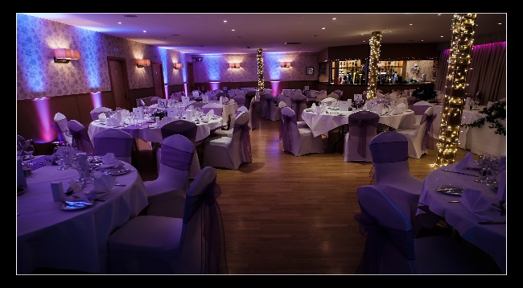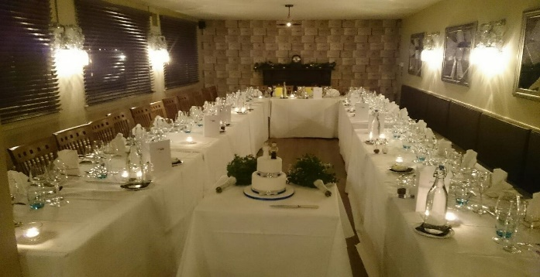
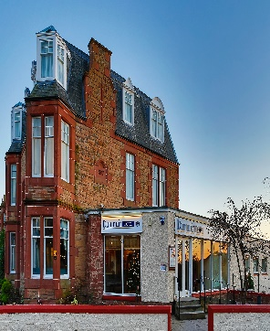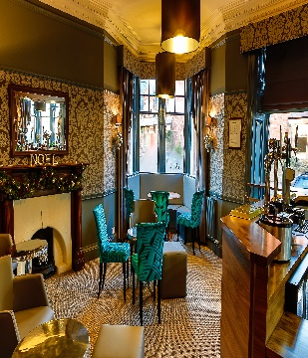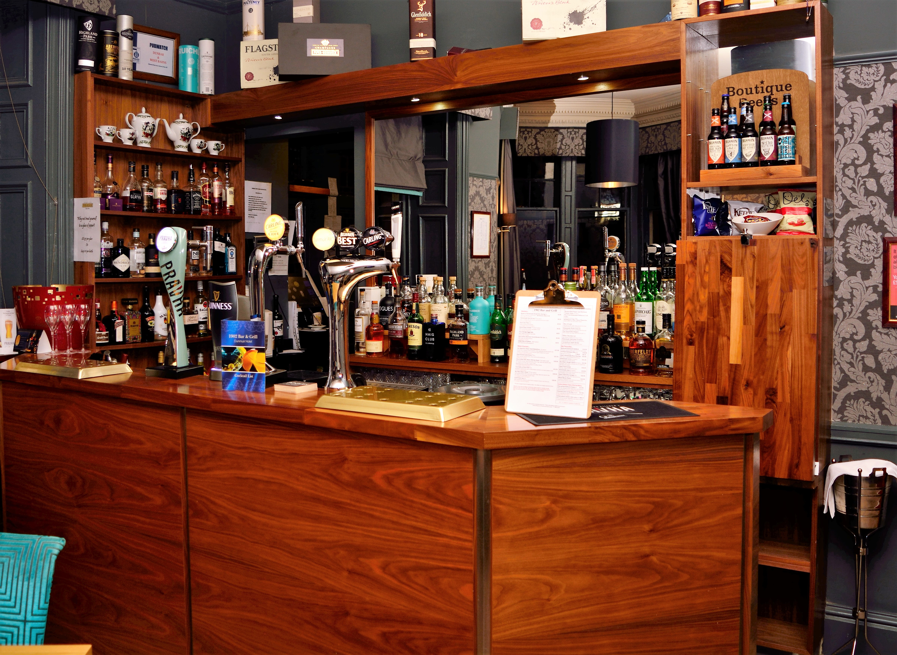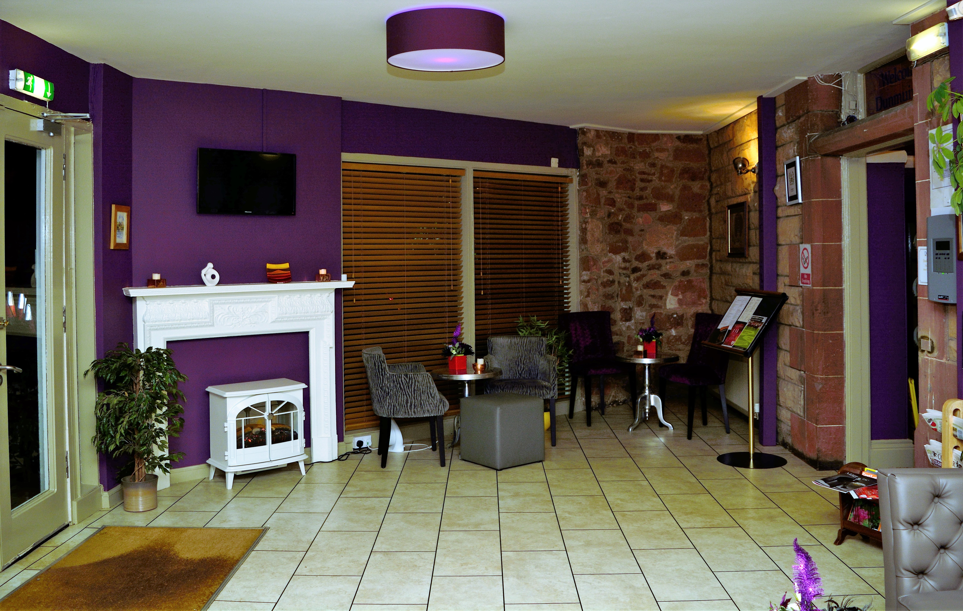

Each and every wedding is quite individual and as such we discuss every enquiry on a one to one basis

We are pleased to offer a selection of menu options including: -

Three course choice menu with specially selected drinks to accompany
Evening Buffet Selection from £7.95
Menu selector to put your own menus together

When selecting one of our menus we will include:-
Dedicated co-ordinator throughout
Red Carpet
Complimentary Bridle Room for bride and groom with full Scottish breakfast
Preferential rates for accommodation for friends and family

To discuss your requirement please call Lesley or Philip on 01368 862033 or e-mail info@dunmuirhotel.co.uk

Menus

Menus and drinks packages

The Dunmuir £36.00

Served with Bronze Drinks Package

Trio of Melon
served with a fruit coulis

Lightly Spiced Lentil & Vegetable Broth

oooOOOooo

Steak Pie
Served with local seasonal vegetable and potatoes

Baked Chicken Breast stuff with Haggis
Served with a whisky cream sauce

Char-grilled Halloumi Steak
With roast Mediterranean vegetables and scented Rosemary potatoes

Served with local seasonal vegetable and potatoes

oooOOOooo

Banoffee Pie
with vanilla ice cream and chocolate shavings

Local berry and meringue mille-feuille
with strawberry coulis

oooOOOooo

Coffee and Tablet

Bronze Drinks Package to accompany all menus:-

Choice of House White or Red Wine or freshly squeezed Orange Juice on arrival

A glass of Red or White Wine with the meal

A glass of Sparkling Wine for the toast

The Belhaven -£45.00

Served with the Bronze Drinks Package

Duck and Orange Terrine
with Melba Toast

NB Gin Sorbet

Confit Rack of Border Lamb
with Herb and Parmesan Crumble with Straw Potatoes and Crème Fraiche
Chefs selection of local seasonal vegetables and potatoes

Eton Mess

Tea of Coffee with tablet

The Goldenstones - £59.00

Served with the Bronze Drinks Package

Local Lobster Salad
garnished with avocado tartar, Belhaven smoked salmon and citrus vinaigrette

Sorbet Cocktail

Grilled Fillet Steak
Served Medium Rare with a potato gratin , asparagus tips and a wild mushroom cream

Baked Apple Stuffed with Dried Fruits & Rum
topped with oatmeal crumble and cinnamon ice-cream

Coffee and Petit fours

Childrens Menu £6.95 Age 4 to 11

Starters
Heinz Cream of Tomato Soup
Melon Boat
Crudités – Carrot, Cucumber, Celery, Pepper and Mayo Dip

Main Course
Breaded Chicken Goujons
Fish fingers & Fries with either peas or beans
Penne Pasta in a tomato sauce
Grilled Pork Sausages & Fries or Mash with peas or beans

Dessert
Selection of Ice-cream
Chocolate mousse
Fresh Fruit Salad

Silver Drinks Package
Additional £10.95 per person

Choice of wine, house spirit or soft drink of choice on arrival

Glass of Luis Felipe Edward Lot 66 Sauvignon Blanc
or
Glass of La Campagne Cabernet Sauvignon
Served with the meal

Glass of House Champagne for the toast

Gold Drinks Package
Additional £18.95 per person

Glass of Champagne on arrive

Half a bottle of Red or White wine served with the meal

Glass of Champagne for the toast

Why not Add Canapes for your guests?

Canapes

(Your choice of Canapes per person 4 - £7.25, 6 – £9.95)

Selection of from below

Mini Thai Basket
Smoked Salmon Mini Parcels
Smoked Salmon Blinis
Mini Fish ‘n’ Mushy Peas
Crispy Prawn Purses
Mini Sausage and Mash
Chicken and Chorizo Skewers
Mini Curry Selection
Cocktail Vegetable Satay
Chicken Liver Terrine
Quail Egg Terrine
Smoked Salmon and Asparagus Pin Wheel

Menu Selector – put together your own menu from below:-

To Start…

Choice of soup from £4.45
Chefs homemade Duck and Orange Pate with Melba Toast £6.25
Traditional Prawn Cocktail with brown bread £7.25
Chilled Medallions of Monkfish with Mixed Seafood Cocktail and Piquillo Pepper Vinaigrette £8.25
Local Lobster Salad, garnished with Avocado tartar, Belhaven Smoked Salmon and Citrus Vinaigrette £19.25
Trio of Chilled Melon and Parma Ham £5.95
Warm Tartlet Stuffed with Roasted Peppers Caboc Cheese and Watercress dressed with a balsamic glaze £5.45
Trio of Hornigs Haggis Bon Bon’s served with a Whisky Mayonnaise £6.45

Main Courses..

Chicken Breast stuffed with Hornigs Haggis, Served over Creamed Potatoes and Local Seasonal Vegetables and a Whisky Cream Sauce £13.95
Monkfish Marinara with Confit Potatoes and Tapenade tuile £15.95
Grilled Shaw’s Fillet Steak with Potato Gratin, Asparagus Tips and a Wild Mushroom Cream £34.95
Confit Rack of Border Lamb with Herb and Parmesan Crumble with Straw Potatoes and Crème Fraiche £19.95
Pan Seared Halibut with Wild Garlic Crushed Potatoes and a Light Shellfish Broth £15.95
Petit Ratatouille Baked in a Herb and Parmesan Crumble with Straw Potatoes and Crème Fraiche £12.95
Noisettes of Pork Fillet with Heritage Potatoes, Roasted Shallots and a Sweet Spanish Sherry - Pedro Xemenez Glaze £17.95
Pan Fried Venison Fillet carved over a Black Pudding round with Dauphine Potato and pan jus £23.95
Char-grilled Halloumi Steak with Roast Mediterranean Vegetables £15.95

Puddings….

Eton Mess £5.25
Local Berry and Meringue Mille-feuille with Sweet Cream and Strawberry Coulis £5.45
Banoffee Cream Pie with Vanilla Ice-cream and Chocolate Sauce £5.25
Baked Apple Stuffed with Dried Fruits and Rum Topped with Oatmeal Crumble and Cinnamon Ice-Cream £5.45
Warm Sticky Toffee Pudding with Caramel Ice-cream and Treacle Sauce £5.25
Selection of three Doddingtons Ice-creams @ £5.25

Coffee & Tablet £3.25
Coffee and Petit Fours £4.95

Evening Buffet
Choose from the below selector

4 items £7.95
6 items £10.45

Assorted Sandwiches – Tuna, Egg Mayonnaise, Ham & Mustard, Cheese & Chutney, Turkey Salad, Cream Cheese & Cucumber, Belhaven Smoked Salmon * Prawn Marie Rose * (* £1.50 denote supplement of per unit)
Mini Bacon Rolls
Cajun or Barbeque Wings
Mini Meat Pasties
Baby Baked Potatoes with Cheese & Bacon or Cheese & Chilli
Baked Flat Breads with Tomato Basil and Mozzarella
Chicken Satay or Tikka Skewer with Yogurt Dip
Assorted Mini Quiches
Deep Fried Haggis Balls with Whisky Mayo
Cocktail Sausages on a stick
Skewered Buffalo Mozzarella Balls, Cherry Tomato and pesto

Add a Sweet Treat?

£4.95 per item

Fresh Fruit Kebabs
Mini Chocolate Éclairs
Mini Chocolate Brownie
Lemon Drizzle Cake

Please note these prices are subject to market changes and for 2019 only

Testimonials – just a few from our recent weddings…….

Thanks
We had our wedding at the Dunmuir in April 2018 and from start to finish the staff were very professional, organised and extremely accommodating. Nothing was too much for the staff and all our guests commented on how friendly and welcoming the staff were, and most importantly, how good the food was!!!
Phil definitely took a lot of the wedding planning stress away with his super organising skills & prompt replies to my hundreds of email enquiries!�
I would definitely recommend you take a look at this hotel for your next event
Thanks so much guys x

Wedding and a wee holiday
Excellent hotel absolutely no complaints food very high standard staff could not do enough for you superior room ( no 2 very comfortable ) ,unable to think of any improvements Just Perfect

Excellent wedding venue

The Dunmuir Hotel have blown us away. We have had the most amazing experience getting married there this past weekend. The staff are extremely polite, helpful and always smiling. A special mention to Phillip our MC (Master of Ceremonies). Phillip has been the sole contact for us since we booked the Dunmuir all those months ago. Everything ran smoothly and nothing was any trouble. All the guests at the wedding have also mentioned to me how impressed they were. Again I cannot complain everything was perfect. Thank you. Joanne & Jamie

